National 5 Computing Science

Assignment

Assessment task
Task 3: web design and development

This document provides information for teachers and lecturers about the coursework component of this course in terms of the skills, knowledge and understanding that are assessed. It must be read in conjunction with the course specification.

Valid for session 2018–19 only.

This assessment is given to centres in strictest confidence. You must keep it in a secure place until it is used.

This edition: January 2019 (version 1.0)

© Scottish Qualifications Authority 2019

Task 3: web design and development
Too Good to Throw Away is a charity clothes shop. They would like a web page to encourage donations of clothes.

It will have a:

- heading with the title “Too Good to Throw Away!”
- graphic of clothes
- coloured section with a subheading entitled “What we need”.
- numbered list (from 1 to 5) detailing the items the charity shop would like donated
- coloured section with a subheading titled “What we have in stock”
- video showing the current stock.

3a State two functional requirements for this web page.

Functional requirement 1
(1 mark)
Functional requirement 2
(1 mark)

Candidate name________________________ Candidate number______________

3b. The wireframe design of the page (annotated with required styles) is shown below.

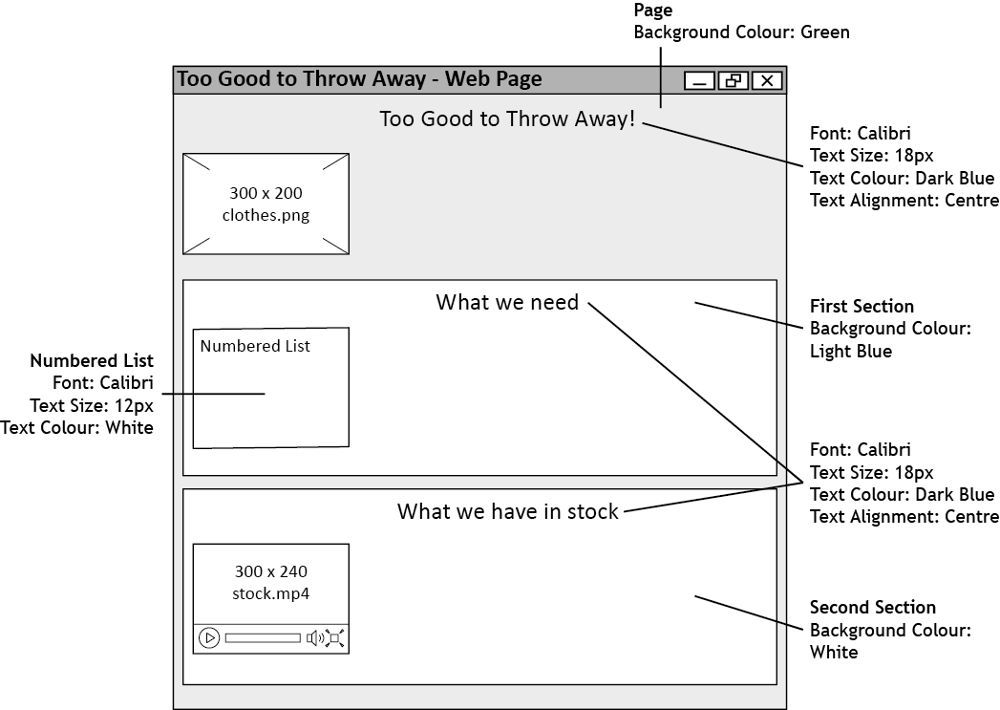

Your teacher or lecturer will provide you with the following two files:

- clothes.png
- stock.mp4

The following five items should be listed under the heading ‘What we need’.

1. School Uniforms
2. Blazers
3. Gym Clothes
4. School Bags
5. Black Shoes

Implement the wireframe design using HTML and internal CSS.
(7 marks)

Print evidence of the following:

- HTML with internal CSS
- Web page as viewed in a browser
3c Describe two tests that could be performed on this web page.

Test 1
(1 mark)
Test 2
(1 mark)

3d With reference to your solution, evaluate your web page by commenting on the following:

Fitness for purpose
(1 mark)

Candidate name________________________ Candidate number_____________

